6A^{th} Grade: Unit 9, Lesson 6
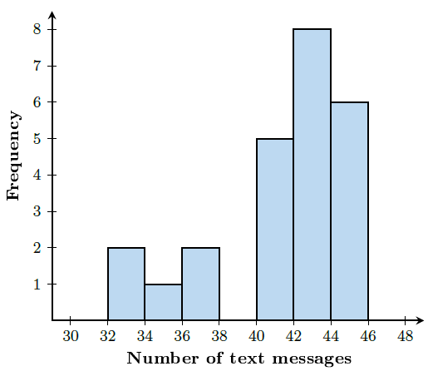
- Where does the peak of the data lie in the histogram shown?

The peak of the data lies between 42-44.

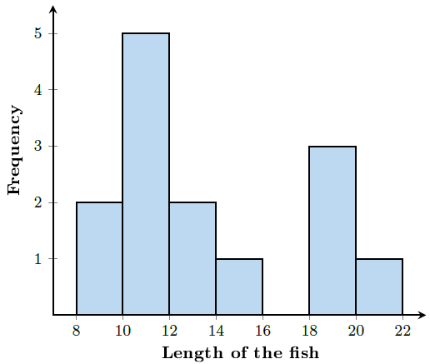
- Where does a gap exist in the histogram shown?

The gap exists between 16-18.

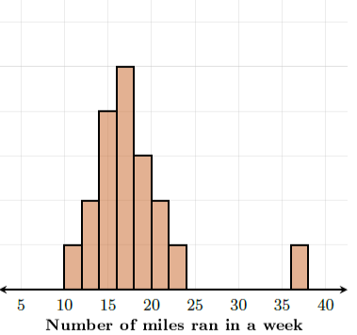
- Where in the data displayed in the histogram provided, is there an outlier?

36 miles

